Name: K.Nandan Sai
Roll no: 2620040064
Section: 13
JAVA HACKATHON
Question 1: Household Water-Usage & Billing Monitor
1a) Data Types:
Write a Java program to store and display the following details of a household:
Number of family members – integer
Water consumed in litres – decimal value
House number – integer
Water usage status – character
Use appropriate Java data types for each value and display all the details.

Ans)
//1a
import java.util.Scanner;
class DataTypes1a {
public static void main (String[] args) {
Scanner sc = new Scanner(System.in);
System.out.print("Enter no of Family Members: ");
int mem = sc.nextInt();
System.out.print("Enter Consumed liters: ");
double litre = sc.nextDouble();
System.out.print("Enter House Number: ");
int house = sc.nextInt();
System.out.print("Enter Usage Status: ");
char status = sc.next().charAt(0);
System.out.println("Family Members: "+mem);
System.out.println("Litres Consumed: "+litre);
System.out.println("House Number: "+house);
System.out.println("Usage Status: "+status);
}
}

Output:-

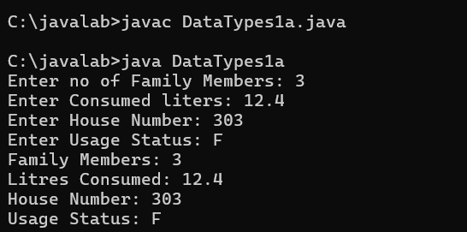

1b) If-Else Condition:

Write a Java program to calculate the water bill based on water consumption. Read the water consumption in litres.

If consumption is 500 litres or less, the bill is Rs.100.
If consumption is more than 500 litres, the bill is Rs.200.
Use an if-else statement and display the water bill.

Ans)
import java.util.Scanner;
class IfElse1b {
public static void main (String[] args) {
Scanner sc = new Scanner (System.in)
System.out.print("Enter Number Of Litres Consumed: ");
double litre = sc.nextDouble();
if (litre<=500.0) {
System.out.println("Your Bill Is Rs.100");
}
else {
System.out.println("Your Bill Is Rs.200");
}
}
}

Output:-
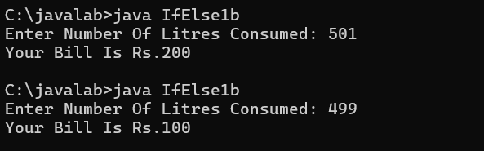

1c) Methods:

Write a Java program to calculate the total water consumption of a household using a method
Create the following method:
calculateTotal(int morningUsage, int eveningUsage)
The method should return the total water consumption. Read the morning and evening water usage from the user, call the method, and display the total consumption.

Ans)
//1c) Methods:
import java.util.Scanner;
class Method1c {
static int calculateTotal(int morningUsage, int eveningUsage) {
return morningUsage + eveningUsage;
}
public static void main(String[] args) {
Scanner sc = new Scanner (System.in);
System.out.print("Enter Morning Water Usage: ");
int morningUsage = sc.nextInt();
System.out.print("Enter Evening Water Usage: ");
int eveningUsage = sc.nextInt();
int total = calculateTotal(morningUsage,eveningUsage);
System.out.println("Total water consumption: " + total + " litres");
}
}
Output:-
